Synopsis

Project Title:
Heart Disease Prediction System

Problem Id:18

Student Name: SARTHAK SINGH CHAUHAN
University Roll number: 2028842
Section: U

Student Name: HEMANG SETHI
University Roll number: 2028726
Section: U

Student Name: HEMANT SINGH
University Roll number: 2028727
Section: U

Problem Description:
Heart disease remains one of the primary causes of mortality worldwide. Early detection of cardiovascular risk can significantly reduce complications and improve patient outcomes. This project proposes a Heart Disease Prediction System that leverages machine learning techniques to analyze patient data and predict the likelihood of heart disease.
The system uses clinical features such as age, gender, blood pressure, cholesterol levels, chest pain type, fasting blood sugar, ECG results, and other relevant indicators. Raw healthcare data often contains missing values, noise, and inconsistencies; therefore, a robust data preprocessing pipeline is required to ensure data quality.
After cleaning, feature scaling is applied to bring all variables to a comparable range, which is essential for distance-based algorithms such as KNN. Feature selection techniques are employed to retain only the most informative attributes, reducing overfitting and improving computational efficiency.
The system employs Logistic Regression for probabilistic prediction and K-Nearest Neighbors for instance-based classification. The final model assists healthcare professionals in identifying high-risk patients and recommending preventive measures such as medication, diet control, and lifestyle changes.

- Steps of Implementation:
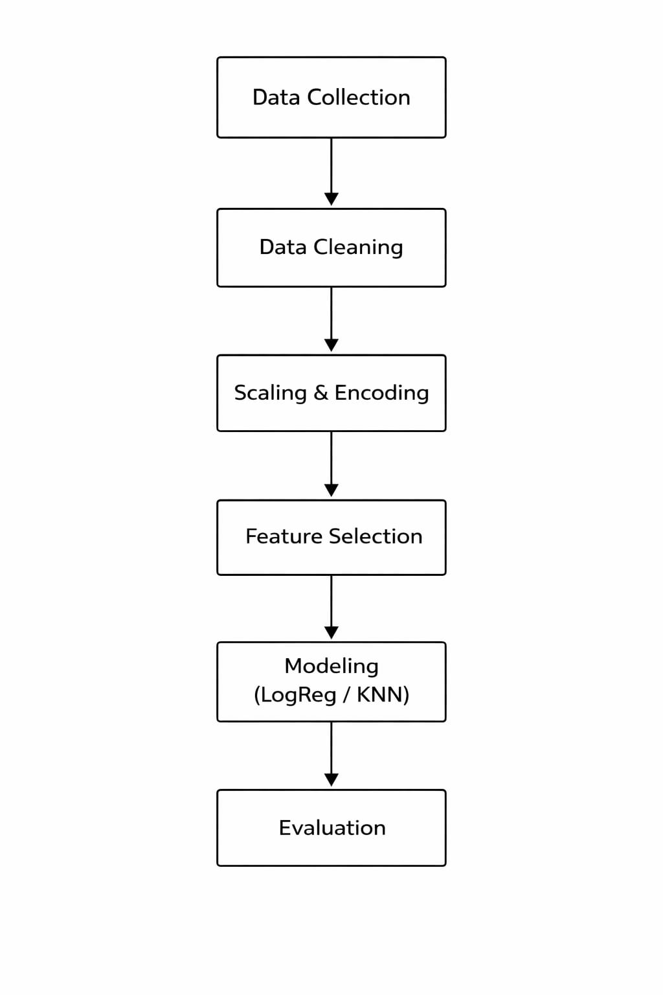
Fig. 1 Machine Learning Pipeline

- Expected Modules/ Libraries to be used :
Pandas:
Pandas is a powerful open-source Python library used for data manipulation and analysis.
It provides data structures like DataFrame and Series to handle structured data efficiently.
Pandas supports tasks such as cleaning, transforming, and analyzing datasets with ease.
NumPy:
NumPy is a fundamental Python library for numerical computing and working with arrays.
It provides fast, efficient multi-dimensional array objects and mathematical functions.
NumPy is widely used for scientific computing, data analysis, and machine learning.
Scikit-Learn:
Scikit-learn is a popular Python library for machine learning and data analysis.
It provides simple and efficient tools for classification, regression, clustering, and preprocessing.
Built on NumPy and SciPy, it helps build and evaluate models with easy-to-use APIs.
Matplotlib:
Matplotlib is a popular Python library used for data visualization and plotting graphs.
It allows users to create charts like line plots, bar graphs, histograms, and scatter plots.
Matplotlib helps present data clearly with customizable figures and visual styles.

Seaborn:
Seaborn is a Python data visualization library built on top of Matplotlib.
It provides a high-level interface for creating attractive and informative statistical graphics.
Seaborn simplifies complex visualizations like heatmaps, pair plots, and distribution plots.

- Expected Evaluation metrics and Plots to be used:
Accuracy:
Accuracy in Python (machine learning) is a metric used to evaluate classification models.
It measures the proportion of correct predictions out of the total predictions made.
In libraries like scikit-learn, accuracy can be calculated using functions like accuracy_score.

Precision:
Precision in Python (machine learning) is a metric used to evaluate classification models.
It measures the proportion of true positive predictions out of all predicted positives.
In libraries like scikit-learn, precision can be calculated using functions like precision_score.

Recall:
Recall in Python (machine learning) is a metric used to evaluate classification models.
It measures the proportion of true positive predictions out of all actual positive cases.
In libraries like scikit-learn, recall can be calculated using functions like recall_score.

F1-Score:
F1 score in Python (machine learning) is a metric that combines precision and recall.
It is the harmonic mean of precision and recall, balancing both metrics.
In libraries like scikit-learn, it can be calculated using functions like f1_score.

Confusion Matrix:
A confusion matrix in Python is a table used to evaluate classification model performance.
It shows counts of true positives, true negatives, false positives, and false negatives.
In libraries like scikit-learn, it can be created using the confusion_matrix function.

ROC Curve:
The ROC curve in Python is a graphical tool to evaluate the performance of binary classifiers.
It plots the True Positive Rate (sensitivity) against the False Positive Rate at various thresholds.
In libraries like scikit-learn, it can be generated using functions like roc_curve and visualized with Matplotlib.

- Required topics from the subject:
1. Different Types of Plots
Plots help visualize data patterns and relationships (e.g., line plot, bar chart, histogram, scatter plot).They are useful for understanding trends, detecting outliers, and presenting results clearly.

2. Pointers (in context of ML programming - mainly C/C++)
Pointers store memory addresses and help in efficient data handling, especially with large datasets.They allow dynamic memory allocation and faster data manipulation in low-level implementations.

3. Functions
Functions are reusable blocks of code used to perform specific tasks like data preprocessing or model training.
They improve code modularity, readability, and reduce repetition in ML pipelines.

4. Data Preprocessing
This step involves cleaning data, handling missing values, and transforming features.It ensures the dataset is suitable for training accurate and reliable ML models.

5. Feature Selection
Feature selection identifies the most important variables for prediction.It reduces model complexity, improves performance, and avoids overfitting.

6. Model Building
This involves choosing algorithms like Logistic Regression, KNN, or Decision Trees.The model learns patterns from training data to make predictions on new data.

7. Evaluation Metrics
Metrics like accuracy, precision, recall, and F1-score measure model performance.They help compare models and ensure the chosen model is reliable.
- Platform Required:
Visual studio
Jupyter notebook
Python idle.
- Books and Link Sources:
1. “Hands-On Machine Learning with Scikit-Learn, Keras, and TensorFlow” – Aurélien Géron
Provides practical knowledge about implementing machine learning algorithms and building predictive models.

2. “Python Machine Learning” – Sebastian Raschka
Explains machine learning concepts and demonstrates how to implement them using Python libraries.

3. Scikit-learn Official Documentation
https://scikit-learn.org
Provides detailed information and examples for machine learning algorithms used in the project.

4. Kaggle Dataset Repository
https://www.kaggle.com
Source for publicly available datasets including traffic accident datasets used for training and testing models.

